Карагандинский государственный медицинский университет

Кафедра иностранных языков
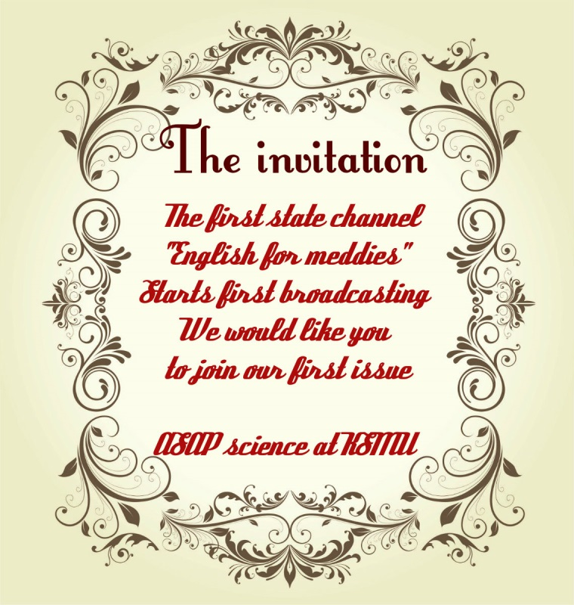

Методические рекомендации для практических занятий

Тема: Казахстан и страны изучаемого языка.
Артикли: определенный, неопределенный, нулевой.
Дисциплина: «Иностранный язык»

Специальность: Медико-профилактическое дело

Курс: 1
Составитель: Дашкина Т.Г.
Объем учебных часов: 2

ОТКРЫТЫЙ УРОК ДЛЯ СТУДЕНТОВ ОДНОЙ ИЗ МЕДИЦИНСКИХ СПЕЦИАЛЬНОСТЕЙ БЫЛ ПОДГОТОВЛЕН В ФОРМАТЕ ПРОЕКТНО-ОРИЕНТИРОВАННОГО ОБУЧЕНИЯ.

ЛЕГЕНДА: РЕПОРТАЖ ТЕЛЕКАНАЛА ДЛЯ ВРАЧЕЙ, СТУДЕНТЫ – РЕПОРТЕРЫ И УЧАСТНИКИ РЕПОРТАЖЕЙ О: ПОДГОТОВКЕ МЕД. СТУДЕНТОВ К ЭКЗАМЕНАМ, ОБЩЕСТВЕННОЙ ЖИЗНИ, ИСПОЛЬЗОВАНИИ МЕТОДА ПРОЕКТОВ (CASE-STUDY) В ОБУЧЕНИИ МЕДИЦИНЕ.

Караганда 2015 г.

Тема: Казахстан и страны изучаемого языка.
Артикли: определенный, неопределенный, нулевой.
Цель: по завершению занятия студенты способны выражать свои мысли на английском языке с использованием освоенных грамматических структур и соответствующей терминологии.
Задачи обучения:
1. Сравнивать учебную и общественную жизнь студентов-медиков
2. Описывать проектно-ориентированное обучение, как один из АМО, используемых в КГМУ
3. Оценивать врачебную деятельность с точки зрения возможных ошибок и способов их предотвращения.
4. Делать выводы и выражать мнение на английском языке в контексте тематики занятия.
Основные вопросы темы:
1. Работа с грамматикой:
- введение грамматического материала «Артикли: определенный, неопределенный, нулевой».
- выполнение подстановочных упражнений
- выполнение трансформационных упражнений
- применение грамматического материала в устной речи
2. Работа над лексикой:
- введение лексического материала с применением дефиниций
- активизация лексического материала на тексте
- подстановочные упражнения
3. Работа с текстом:
- составление вопросов и плана к тексту
- упражнения для обучения интерпретации текста
- упражнения на контроль понимания основного содержания прочитанного текста
Методы обучения и преподавания: метод малых групп, дебаты, мозговой штурм, дискуссия
Литература:
На русском языке:
основная
1. Маслова А.М. Английский язык для медицинских вузов : учебник / А. М. Маслова, З. И. Вайнштейн, Л. С.Плебейская. - 5-е изд., испр. - М. ГЭОТАР-Медиа, 2013, 2014. - 336 с.
дополнительная
- Бонк Н.А. Английский шаг за шагом: учебное пособие / Н.А. Бонк, И.И. Левина, И.А. Бонк. - М.: Эксмо. - Ч. 1. - 2015. - 576 с.
- Бонк Н.А. Английский шаг за шагом: учебное пособие / Н.А. Бонк. - М.: Эксмо. - Ч. 2. - 2015. - 384 с. : ил.
- Голицынский Ю. Грамматика. Сборник упражнений : сборник / - 7-е изд. испр. и доп. - СПб.: КАРО, 2014. - 576 с.
- Кондратьева В.А. Немецкий язык для студентов-медиков : учебник / В. А. Кондратьева, Л. Н. Григорьева. - 2-е изд., испр. . - М. : ГЭОТАР-Медиа, 2012. - 400 с
- Лазаренко И.А. Учебное пособие по грамматике английского языка для студентов 1, 2 курсов для всех специальностей КГМУ с приложением "Все об английском языке": учебно-методическое пособие / И. А. Лазаренко; КГМУ. - Караганда, 2012. - 224 с.
На казахском языке:
основная
1. Akhmetova G. M. Advanced English in General Medicine [Мәтін] : ағылшын тілі: оқу құралы / G. M. Akhmetova, T. Zh. Kutebayev. - Алматы : Эверо, 2014. - 284 б.
дополнительная
- Медиева С.К. Медициналық мәтіндер мен жаттыѓулар жинаѓы : оқу-әдістемелік құрал / С. К. Медиева, Г. С. Утемисова ; ҚММУ. - Қараѓанды, 2012. - 196 б.
- Унгарбаева А.А. Аѓылшын тілінің грамматикасы : оқу қ±ралы / А. А. Унгарбаева, А. Б. Нупилова ; КГМУ. - Қараѓанды, 2011. - 88 б.
- Сарыбаева А.О. Аѓылшын тілі бойынша жаттыѓулар жинаѓы : оқу-әдістемелік құрал / А. О. Сарыбаева, Р. С. Кенжебекова ; ҚММУ. - Қараѓанды, 2012. - 132 б.
На английском языке:
дополнительная
- C. McIntosh Cambridge Advanced Learner's Dictionary: учебное пособие / ed. C. McIntosh. - 4th ed. - Cambridge: Cambridge University Press, 2013. - 1844 р. : il.
- Murphy R. English Grammar in Use: a self-study reference and practice book for intermediate learners of English, with answers / R. Murphy. - 4th ed. - Cambridge: Cambridge University Press, 2012. - 384 с:
- Murphy R. Essential Grammar in Use: a self-study reference and practice book for elementary students of English with answers / R. Murphy. - 4th ed. - Cambridge: Cambridge University Press, 2015. - 320 p
- Redman S. English Vocabulary in Use : pre-intermediate & intermediate, vocabulare reference and practice with answers / S. Redman. - 3th ed. - Cambridge : Cambridge University Press, 2011. - 264 р. : il.
Контроль: Выполнение лексико-грамматического теста.

CBL-based lesson
“The 1st TV channel for Meddies (Medical students)”.

“I hear and I forget, I see and I remember, I do and I understand”
Chinese Proverb
In the case-based learning students are suggested to solve the problem, which is real, up-to-date and important for them, which demands great variety of knowledge, background and experience and shows students the direction of getting new ideas and decisions.
A teacher can help with the sources of information, or can only facilitate and navigate the course of a research. The result of a teacher’s advising help must be shown in the investigated, elaborated, debated and solved problem. Pupils, students or followers should gather knowledge from different fields of investigation, direct this knowledge according to their purpose and get real and significant result at the end of work. That is how problem-solving work becomes a part of a case-based study technique.
The case-study technique implies practice by doing, research and preparation work in the field of observation.
There are several stages of case-study lessons’ preparation:
1. Selection of the subject (Medical English at KSMU on the basis of the given educational program)
2. Data gathering (debates upon a medical issue; medical advertisement; study of vocabulary and grammar at KSMU; the report about CBL in KSMU; social life in KSMU)
3. Data analysis (all information was found and discussed during the 2-months’ period of preparation)
4. Emergence of the model

The model chosen for the lesson was up to the Medical University educational course. The model was titled “The 1st TV channel for Meddies (Medical students)”. Students were given their tasks and roles and became co-workers at the “English for meddies TV Channel”. One of the students were announcers, others fulfilled the roles of reporters and actors.
The TV-channel’s issue contained several parts:
- Introductory (heated debates upon a medical topic);
- Advertisement about innovations in medicine;
- Reports from KSMU (about Educational and social life of KSMU students). Educational life contained the topic of the practical class and was presented in the form of Team-based learning; Social life reports included extracts from the creative works prepared by the class participants: songs’ translations, storytelling and etc.
- Breaking news. Also there was a report from CBL lessons of KSMU: students prepared the description of a medical case and tried to solve it. This entire lesson was given as a part of TV- broadcasting.
- Group and individual feedback

The course of the lesson

Welcome to the 1st issue of our TV-channel: “English for meddies”. Nowadays we are going to have a lot of interesting medical issues to discuss, solve, remember and get surprised. Stay tuned…we are going to start!
TV HOST 1:Our first piece is about heated debates with the subject: “Preventable medical mistakes: Who is to blame?” Firstly, let’s watch and discuss the Physician’s Oath (1.5 MIN). The second video to discuss is about your safety when being a patient in the USA local hospitals (2.5 MIN). The third video is about 5 worst medical mistakes (4 MIN). Having watched the videos, let’s give our audience answer some questions, and express opinions
Who is guilty in patient’s deaths:
- Doctors?
- Inexperienced medical staff?
- Situations at work?
- Lack of rest and sleep for doctors?
- Self-treatment of the patients?
Give your PROs and CONs (10 MIN: 5 MINUTES – EACH TEAM; 2.5 MIN – THE LEADER, 1.5 MIN – THE SPEAKER; 1 MINUTE TO DISCUSS EVERYTHING INSIDE THE TEAM)

TV HOST 2Don’t change the channel. Here is the short advertisement (Colgate innovations; i-root apex locators in dentistry, 3 MINUTES)

TV HOST 1Our next report is from one of the biggest and prestigious medical Universities of Kazakhstan – KSMU. The first topic to discuss is “Study at KSMU”. Let’s see how it happens at the University with more than 60 year history.(35 MINUTES)

TEACHER: I. Read, translate, and learn the given words and word-combinations:
to visit a tourist a tour to make a tour of (some place) to arrive in to arrive at
a place of interest to get an idea of something to go straight on (ahead) broad / wide (3 MIN)

II. Read and translate the text:
The Republic of Kazakhstan.
The Republic of Kazakhstan is a sovereign, independent, democratic, secular, legal and social state. Its total area is 2.7 million square kilometers. Kazakhstan borders on Russia in the North, China in the East, the Kyrgyz Republic, Uzbekistan and Turkmenistan in the South, and the Caspian Sea in the West. The climate of the Republic of Kazakhstan varies widely throughout the country. The landscape of Kazakhstan is diverse. There are vast lowlands and high mountains, but steppes and semi deserts predominate on the largest part of the country. There are a lot of rivers in the Republic. The main rivers are the Irtysh, the Ural, the Chu, and the Syrdarya. There are some natural reservations, e.g.: Barsakelmes, Aksu-Dzhabagly.
The official language of the country is Kazakh; Russian is the language of interethnic communication, because more than 100 nationalities live in Kazakhstan. According to the most recent data, the population of the Republic is about 17 million.
Kazakhstan is a democratic Republic with the presidential form of government. The main law of the state is the Constitution. The highest representative body is the Parliament, which consists of two chambers: the Senate and the Mazhilis.
Kazakhstan is very rich in mineral resources. There are big deposits of oil, gas, gold, coal, copper, iron ore and others. Industry is presented by mining and processing activities. Manufacturing is also an important industrial branch in Kazakhstan. Manufacture includes iron, steel, mineral fertilizer, and textiles.
National currency is tenge which was issued in November 1993. The Republic celebrates its Independence Day on 16 December.
Now Kazakhstan has a new capital city - Astana. Astana is the center of the Republic. There are a lot of construction projects and Astana is going to be the most beautiful and modern city of Kazakhstan (10 MIN).

III. Answer the questions:
1. What state is the Republic of Kazakhstan?
2. When does the Republic celebrate its Independence Day?
3. What is the official language in our Republic?
4. What is the population of our Republic?
5. What is the total area of Kazakhstan?
6. What countries does Kazakhstan border on?
7. What is the climate of Kazakhstan? (3 MIN)

IV. Say true or false:
1. The Republic of Kazakhstan is a sovereign, independent, democratic, secular, legal and social state.
2. Kazakhstan is very rich in mineral resources.
3. The official language of the country is Kazakh.
4. Kazakhstan's total area is 3.6 million square kilometers.
5. Astana is the center of the Republic. (3 MIN)

V. Complete the sentences:
- Kazakhstan is an independent...
- It is a democratic...
- The President...
- The mineral resources are...
- The Parliament consists... (3 MIN)

VI. Grammar exercise: Study the table and fill in the gaps with appropriate articles (HOME TASK)
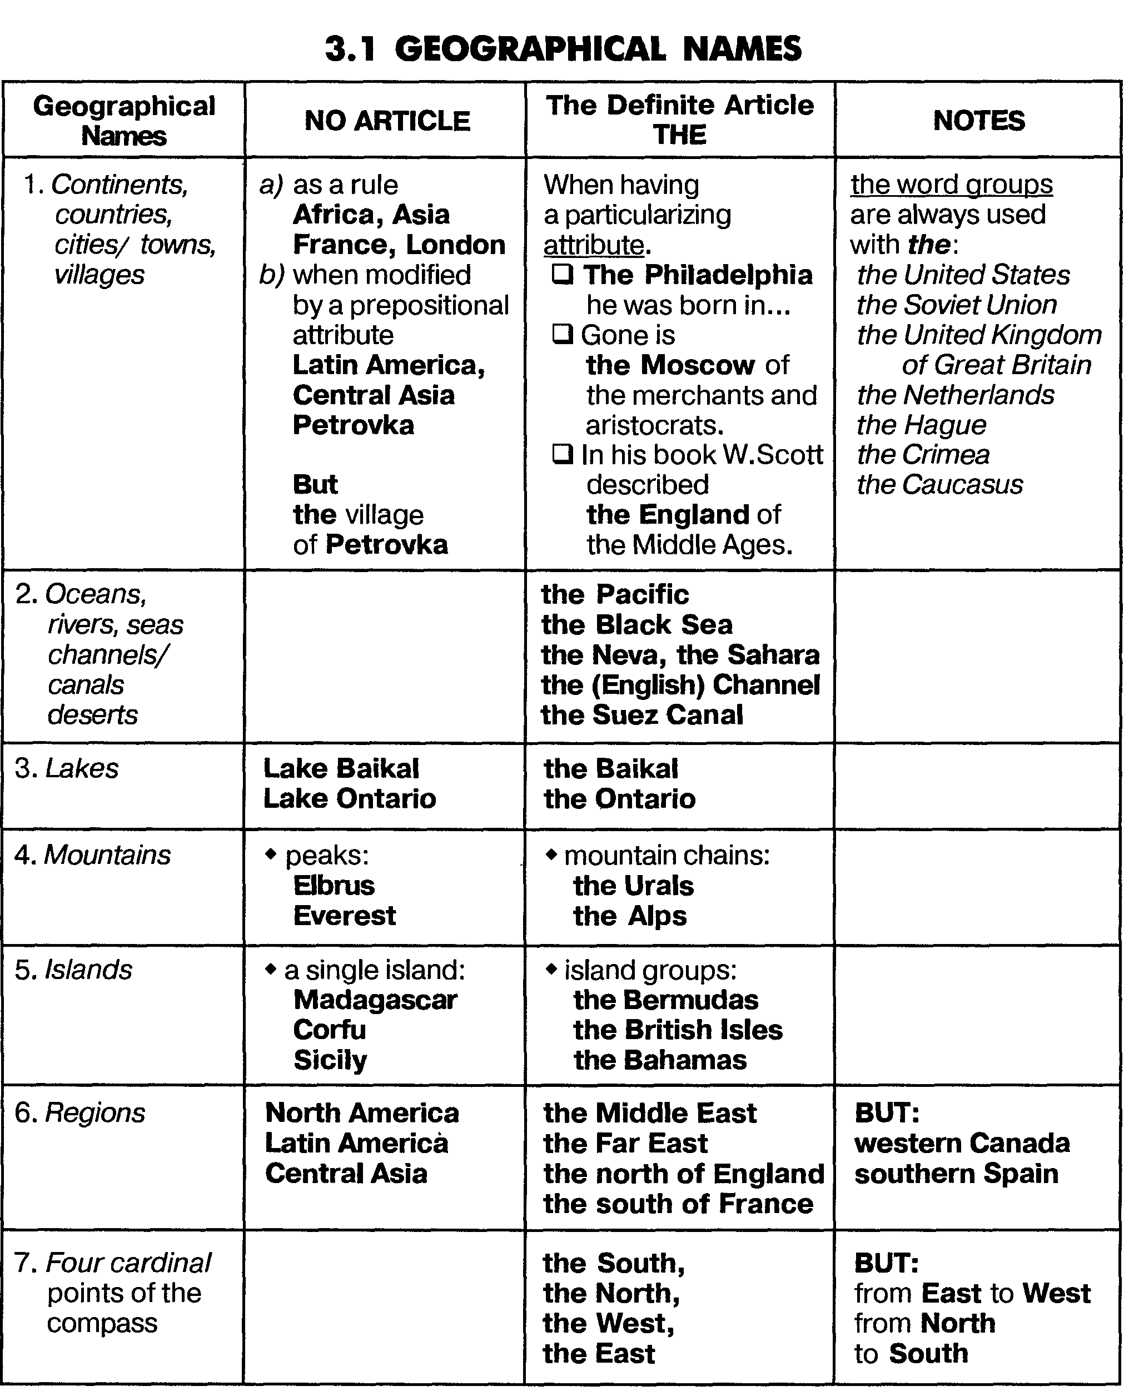
K
azakhstan
I want to tell you about my homeland. My homeland is____ Kazakhstan. Kazakhstan is ____ independent Republic. It is situated in ____ Central Asia. Its population is 16 million. All_____ people of ____Kazakhstan have equal rights and duties. Astana is ____capital of Kazakhstan. _____territory of Kazakhstan is _____ huge. It borders on China in _______ East and _____ Caspian Sea in ______ West, Russian in ______ North and the states of Asia in ______ South. ______ republic occupies _____ territory of more than 2 million square kilometers. ____ Kazakhstan has 14 regions, 84 cities. _____ earth of Kazakhstan is full of ____ iron and _____ gold,____ coal, ____nickel and raw materials. Also Kazakhstan is rich in mineral resources. These reserves formed _____solid base for _____ development of heavy industry. ______leading branch of agriculture is the production of _____wheat, ____sheep rising, and _____horse breeding. Kazakh-is _____ official language of _____ country, but Russian and other languages are spoken here too. Kazakhstan has hundreds of nationalities that's why all people speak their native language.
Great attention is paid to the development of culture and education the Kazakhstan University, the Opera and Ballet Theater named after _____Abai Kunanbayev are well known.
There are _____many big industrial centers in Kazakhstan such as ____Karaganda, Almaty, Semey, and Shymkent.
Kazakhstan is ______ place where space dreams and projects have come into reality. The name of ____Baikonur is known all over the world. We are proud of Kazakhstan and hope it will have _____ great future. Our president now is Nursultan Nazarbayev. _____ president is elected every seven years.
_____ climate is strongly continental. Kazakhstan- has its own flag, anthem and national traditions and holidays. (5-7 MIN)

VII. Make up the plan of retelling to the text. (HOME TASK)

VIII. Retell the text according to your plan. (HOME TASK)
TV HOST 1:IX. Watch our brief report about Kazakhstan (3 MIN)
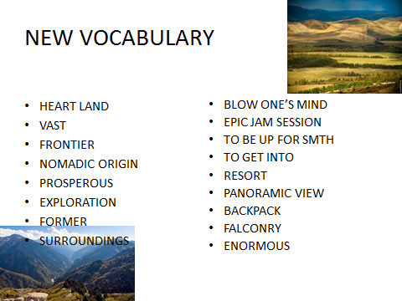

X. Answer the questions according to the video (3 MIN)
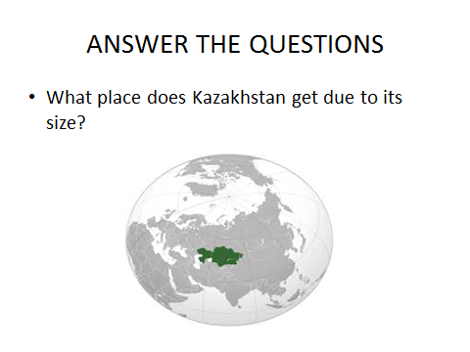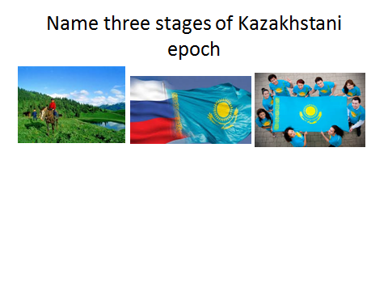
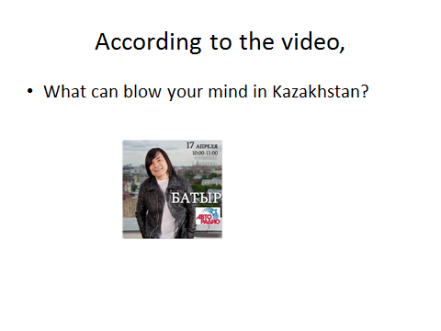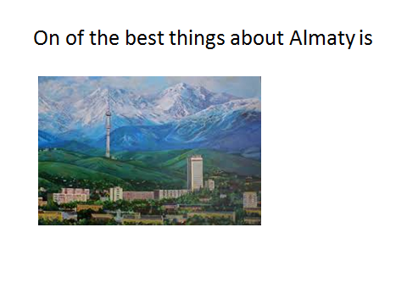

Answer key
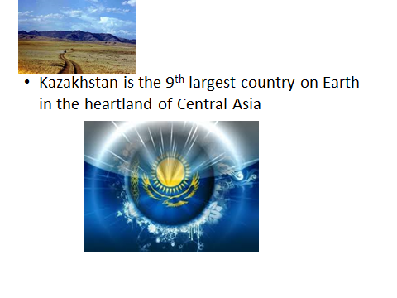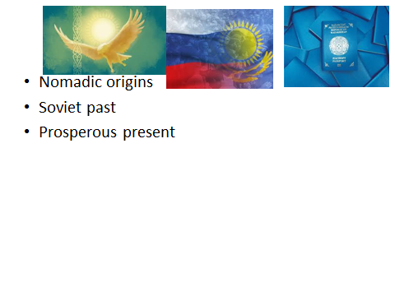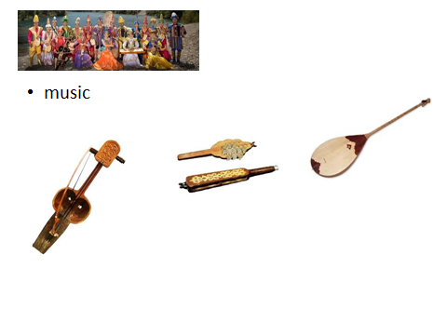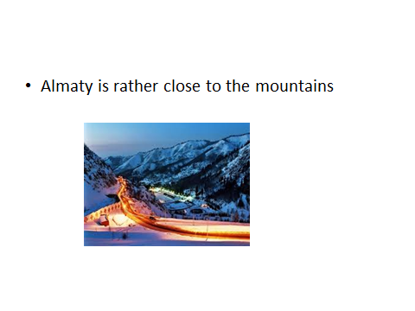
TV HOST 2:XI. Watch our brief report about the United Kingdom of Great Britain and Northern Ireland and answer the questions (6 MIN)
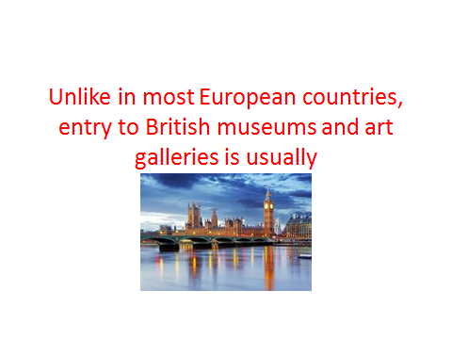

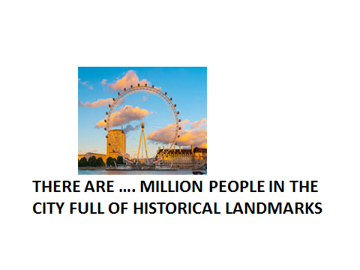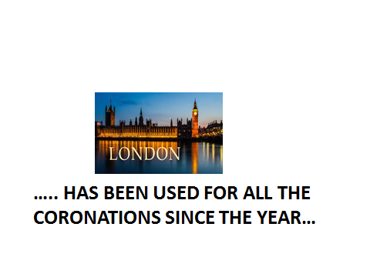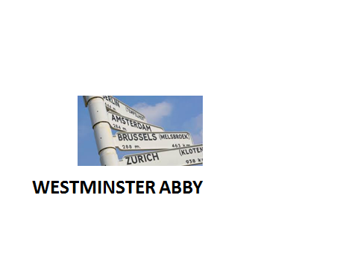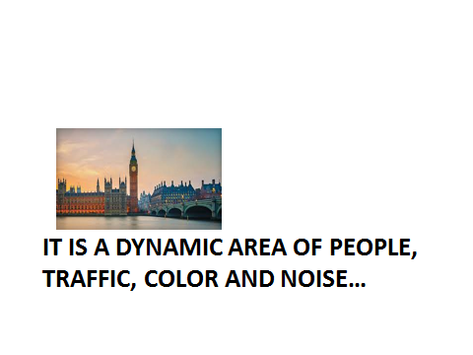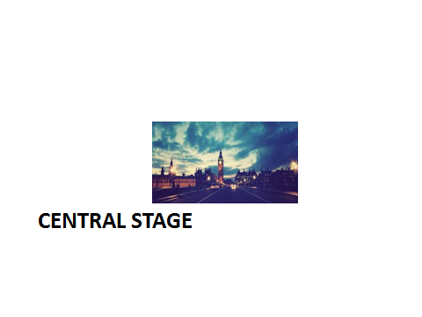
TV HOST 1:XII. Breaking news – The report about the CBL-technique that is used by first-year students of KSMU (“A case of Bronchitis”). (6 MIN)
Let’s watch and discuss the example of Case-study prepared by our reporters: Miss Shaimardanova, Miss Gosman, Mr. Saipov, Mr. Usenov. Watch the video-presentation.

TV HOST 2:XIII. Are you interested in the social life of medical students? If yes, watch our next report from KSMU and you’ll know: how do medical students express their feelings and creative thinking…(7 MIN)
Medical students of KSMU: Translate songs, sing in English, study culture of foreign countries.
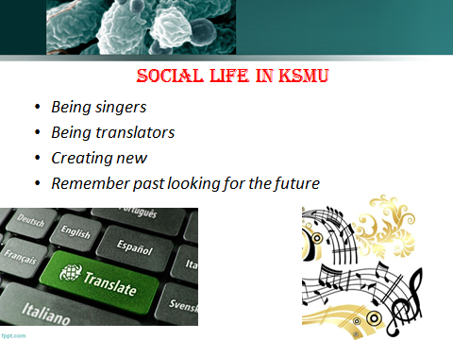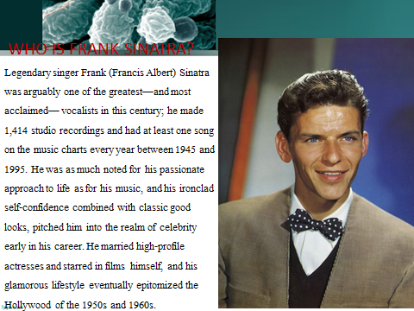
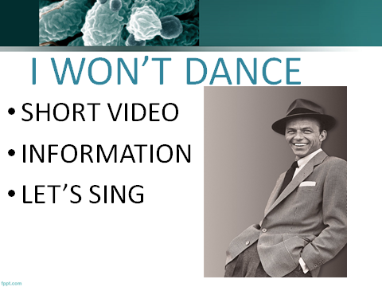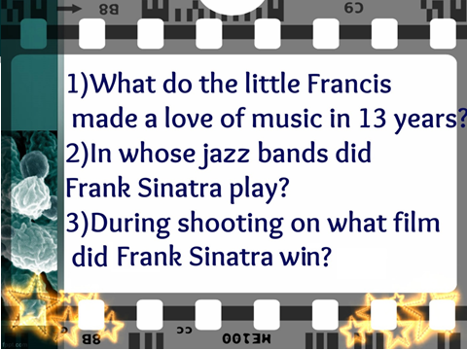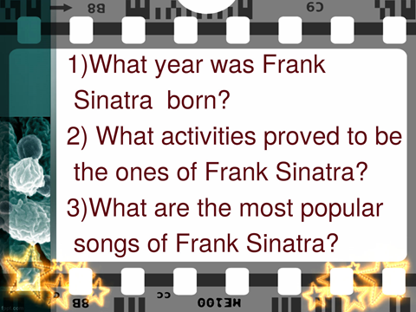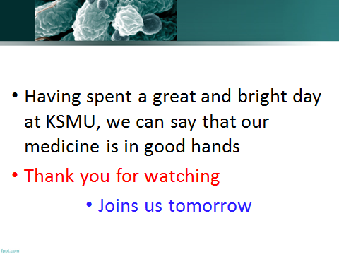

TEACHER:XIV. Group feedback. Please, answer the following questions: (4 MIN)
- How did you like the first issue of the TV-channel “English for Meddies: ASAP science”?
- Were there any difficulties in the preparation for the TV-program?
- Did you like to try on the role of an announcer, TV host, a camera man etc?
- Was it difficult to determine the percentage of patient’s deaths that happened due to medical mistakes?
- Did you like this type of studying?

TEACHER:XV. Individual feedback. (3 MIN)
Fill in the form and try to evaluate your progress in the skill of creating new projects, data gathering and analysis.
Use the points: 5 – Everything was easy to perform; 4 – I needed teacher’s help; 3 - I needed facilitation and navigation of the teacher; 2 – I had some difficulties with the implementation; 1 - I understood nothing and that is why didn’t want to take part in the task.
Stage of the lesson/piece of the issue | Evaluation | I managed to overcome these difficulties (+,-)
Heated debates
Advertisement
Study at KSMU
Report about CBL
Social life at KSMU

*- elements of CBL

APPENDIX 1 (DECORATION MATERIALS)
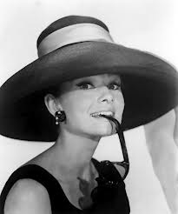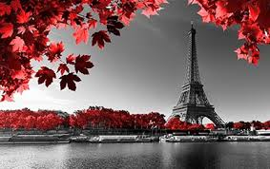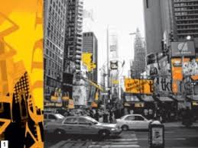

APPENDIX 2

APPENDIX 3

